Last Update: May 29, 2026

Data 360 (Data Cloud)
Sources
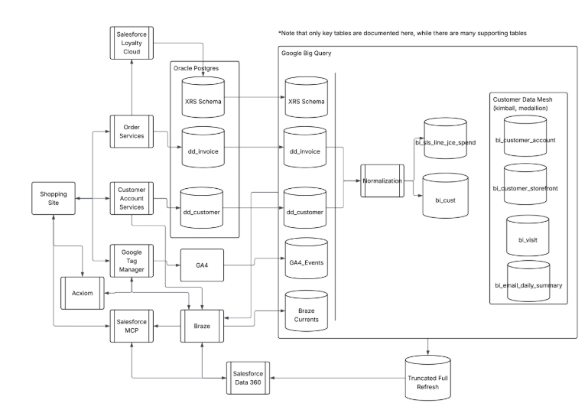
- Google Big Query (Zero Copy or Acceleration)
  - Tables (Customer Data Mesh):
    - bi_customer_account
    - bi_customer_storefront
    - bi_visit
    - bi_email_daily_summary
      - Question: Should we be including any other tables in the sync between Data360 and Google Big Query
      - Updated schema provided
- 3rd party Data Provider
  - We are recommending that Beyond use a 3rd party data provider to enrich your customer records with info described below. (see table below):
  - Question: Are there any other attributes missing?
  - This is complete from entities outside of the data mesh schema via Acxiom, but is being considered for expansion to all brands
# | DataAttributes
1 | person.coreDemographics.gender
2 | person.coreDemographics.adultAge2Year
3 | person.coreDemographics.education
4 | person.coreDemographics.occupation.lowDetail
5 | person.coreDemographics.maritalStatus
6 | person.postalCompliance.dmaSuppression
7 | household.retailBrandPropensitiesFootwear.brandPurchase.rocketDog.rankBase20
8 | household.coreDemographicsFullCoverage.numberOfChildren.withHHZipZip4Inferred
9 | household.coreDemographicsIncomeFullCoverage.estimatedIncome.narrowRanges.precisionLevel
10 | household.coreDemographicsIncomeFullCoverage.estimatedIncome.narrowRanges.withHHZipZip4Inferred
11 | household.coreDemographicsIncomeFullCoverage.estimatedIncome.narrowRanges.precisionLevel
12 | residency.coreDemographics.moveDate.yearMonth
13 | household.interestGroupings.cooking
14 | household.interestGroupings.homeImprovement
15 | household.interestChildrenAndToys.childrensInterests
16 | household.interestGroupings.homeImprovement
17 | household.creditCardBrandPropensities.creditCardTypeHaveFinancial.anyStore.rankBase10
18 | household.financialServicesAssetPropensities.homePropertyOwnsFinancial.realEstateForInvestment.rankBase20
19 | household.generalAttitudeAndBehaviorPropensities.demographicParents.collegeStudents
20 | household.generalAttitudeAndBehaviorPropensities.demographicParents.firstTime
21 | household.generalAttitudeAndBehaviorPropensities.demographicParents.infantsToToddlers
22 | household.ipsosAffluentHome.homeDecoratingOrRemodeling.past12Months.spent10000Plus.rankBase20
23 | household.albionRetailSpendingPropensities.discretionarySpendingFinancial.discretionarySpendingApparel.dollarValue
24 | household.albionRetailSpendingPropensities.discretionarySpendingFinancial.discretionarySpendingApparel.precisionLevel
25 | household.albionRetailSpendingPropensities.discretionarySpendingFinancial.discretionarySpendingHomeFurnishing.dollarValue
26 | household.albionRetailSpendingPropensities.discretionarySpendingFinancial.discretionarySpendingHomeFurnishing.precisionLevel
27 | household.retailBrandPropensitiesFootwear.brandPurchase.avia.rankBase20
28 | place.propertyCharacteristics.propertyType
29 | place.propertyCharacteristics.rpOnly.squareFootage.ranges
30 | place.propertyCharacteristicsDetails.poolPresent
31 | place.propertyMarketValue.estimatedHomeMarketValue.ranges
32 | residency.coreDemographicsFullCoverage.ownerRenter.withHHZipZip4Inferred
33 | residency.coreDemographicsFullCoverage.ownerRenter.precisionLevel
34 | comma separated list of emails that are trimmed, lowered and sha256 hashed per PERSON ID
35 | household.personicxLifestage.segment.code
36 | household.personicxLifestage.segment.precisionLevel
37 | household.personicxLifestage.group.code
38 | household.personicxLifestage.group.precisionLevel
39 | ID of the household the person belongs to

Activation Target
- Marketing Cloud Personalization
- Question: What is the timing and types of audiences you would like to propose from Data360?
  - Near-real time event based communications (per user event)
  - Scheduled segment audiences
  - Product purchase/browse signals from entity A to activate to entity B
  - Value segmentation
  - Lifecycle (based on account create, last purchase, etc)
- Paid Marketing
  - Question: How many target segments are required for paid marketing channels?
  - Per platform we’ll have:
    - Purchasers for Lookalike (Value, Recency, etc)
    - Purchasers non-marketing email subscribers
    - Category, typal purchasers
    - Seasonal holiday purchasers (for lookalike)
    - New Movers
    - College (aged or parent of)
    - Expectant families
  - Question: Besides Google Adwords and Facebook, are there any other paid media channels? (add the following media channels Tiktok, Pinterest)
    - Criteo, Pinterest, TikTok
Marketing Cloud Personalization (MCP)
Web domains and subdomains
- Question: Which domains and subdomains require promotional web campaigns?
  - BBY US (MCP is installed here)
    - Subdomain: BuyBuyBaby
  - Overstock (MCP is installed here)
  - Kirkland Homes (requires new MCP implementation)
  - Container Store (requires new MCP implementation)
  - +1 brand website
- Question: The following table includes initial ideas for suggested promotional web and open time email campaigns. Are there any other campaigns that are required?

 |  | BBY US | Overstock | BuybuyBaby | Kirkland Homes
1 | Set up website beacons and catalog feed | n/a | n/a | Yes | Yes
2 | Update MCP person account records (known users) with unified ID and/or 3rd party enriched customer data attributes (example Income level) from Data 360 | Yes | Yes | Yes | Yes
3 | Web campaign #1: Serve up a mortgage ad targeting self identified users who are interested in a mortgage | Yes | Yes | Yes | Yes
4 | Web campaign #2: Ingest household income into Salesforce recommendations to serve higher price items to customers with higher incomes.  Also include Acxiom personas, etc to inform Einstein product recs | Yes | Yes | Yes | Yes
5 | Web campaign #3. Target households who have recently moved with dedicated creative-> key expansion and persona opportunity | Yes | Yes | Yes | Yes
6 | Web campaign #4 Summer targeting/expansion opportunity as parents get kids ready to head to college | Yes | Yes | Yes | Yes
7 | Web campaign #5: Target patio category with 'small space' approach (bistro sets) for apartment and condos vs bigger patio furn (patio sofas) for single family homes. | Yes | Yes | Yes | Yes
8 | Email campaign #1: Serve up a open time email content box for Braze to use in sending mortgage follow email content | Yes | Yes | Yes | Yes

